



# Letter Of Transmittal

Qurat-ul-ain,

Gulshan Iqbal, Karachi.

Dr. Tehmina Faisal,

Karachi University,

Main University Road, Karachi.

Karachi, Sindh, 75270.

Respected Dr. Tehmina,

I submit below a research paper on the topic revolving around Factors that Affect Employee motivation, specifically regarding Dow University Hospital. It is compliant with all rules laid by Karachi University and the guidelines provided are strictly adhered to.

The main purpose of this research is to dive deep into the topic of how motivation can be fluctuated within a workplace, under the light of prestigious studies and reports. Furthermore, this research paper is meant to elaborate on how motivation can impact the hospital services provided to patients, with a survey conducted on Dow University Hospital Employees.

If you have any concerns or queries, please feel free to contact me via email. I hope this research paper will merit your approval and I look forward to it.

Sincerely,

Qurat-ul-ain.

Table of Contents

Letter Of Transmittal 2

Abstract 5

CHAPTER 1 6

Introduction 7

Problem Statement 9

Objectives 9

Research questions 10

Significance of this study 10

Organizational Leaders in Pakistan 10

Scholars 10

Trade Unions 10

Research Methodology 11

Introduction 11

Sampling and Population 11

CHAPTER 2 14

Literature review 15

Introduction 15

Intrinsic factors that impact employee motivation 15

Trust 15

Fair treatment in the workplace 16

Work-life balance 16

Recognition and appreciation 17

Skill variations 17

Meaningful work 18

Responsibility 18

CHAPTER 3 19

Introduction 20

Data Collection 20

Data Presentation: 21

Data Analysis 21

CHAPTER 4 22

Conclusion 23

Recommendations 23

References 24

# Abstract

The study's goal was to identify the factors that impact employee motivation in Pakistani organizations. The study was led by 3 main research questions that you will read in Chapter 1.

The focus organization was Dow University Hospital in Pakistan, and a descriptive research design was used. The study's populations were employees of Dow University Hospital in Pakistan. The study population included 900 employees from diverse functions within the organization.

A sample size of 270 respondents was drawn using the stratified random sampling approach. The data gathering tool was a structured questionnaire produced by the researcher, inspired by another survey conducted in a work presented in 2014.

The study concluded many intrinsic and extrinsic factors that affect motivation levels within employees that including but not limited to salary structure, appreciation as well as work advancements. The main conclusion is that motivation is a highly sensitive topic that is affected by a complex web of factors.



## Introduction

In the current age of globalization, every organization needs to strive at a cut-throat rate to be successful. To do so, they need all hands on deck, especially when it comes to employees. Organizations that recognize the best talent, and their importance and impact on organizational success often succeed in their goals. This is true for every organization, regardless of its operating size or industry. So, they need to start building healthy and beneficial relationships with their employees which can result in task fulfillment with high levels of job satisfaction.

But this approach is not as simple as it sounds just yet. Whatever the main objective may be, organizations need to make it the common goal for every employee that works for them. This requires tactful strategies to cope with competition as well as a contingency plan for when something goes off track.

What many organizational bodies fail to recognize is that their human capital and intelligence are one of their biggest assets that control a majority of the factors that result in company success. The success of human capital commonly results in the success of an organization whereas the failure of human capital often results in high turnover, additional costs, and an overall failure of the organization (Fisher, 2012).

Employers tasked with motivating employees and improving job satisfaction levels and productivity in the workplace develop policies and programs which are both costly and require time. However, there is another side of the picture to view. These motivating programs hold many benefits; from increasing job satisfaction to reducing staff turnover and improving the strengths of each employee.

The mechanism of these motivational programs and policies is 100% dependent on one motivational theory or another. Maslow’s hierarchy of needs is a well-known theory that highlights an important message of human motivation psychology. Employees who feel secure with meeting their needs will be more motivated to work (McLeod, 2007).

The Herzberg theory brought forward motivation factors that improved motivation in employees and hygiene factors which were extrinsic factors that provided no motivation but also were not contributing to dissatisfaction in the workplace. The reason to highlight these theories and their basic mechanisms is to establish that managers have a great stream of information they can use to make informed changes in the workplace to improve motivation.

So with the plethora of motivational theories and methods come their limitations, setbacks, and criticisms. No motivational theory is a sure way of motivating employees and we can take Herzberg’s 2-factor motivational theory as an example.

Herzberg’s 2-factor theory shows high stress on satisfaction but ignored productivity, which is a crucial element to judge the success of motivation in an employee (Alshmemri, 2017). Some experts have expressed that motivation is internal and cannot be invoked by external factors or we come to a cul-de-sac with just one solution. There may be many motivational theories but they are unlikely to apply universally. People with different socio-economic values and backgrounds will have different orientations towards their workplace and hence, an extremely diverse range of motivating factors.

By recalling the above-mentioned points, we come to the concept that inspired this research paper. There is undoubtedly much research on motivational theories however it remains a poorly understood aspect of Human Resource Management. More often we can come across real-life examples of poor motivational practices in workplaces. To do so would require accurate identification of individual human nature. The next step would be to bring about a variety of motives or factors and expand them into workplace policies to improve motivation.

A point to note is that business concepts apply very differently to countries with varying socio-economic and political backgrounds. A developed country with a fair and unprecedented governing body will be able to adapt to HR concepts like employee morale much better than a country that is developing with limited resources and awareness.

Dow University Hospital was founded officially in 2009, to deliver exemplary healthcare services and education. It is a tertiary care University Hospital affiliated with Dow International Medical College, where MBBS and post-graduate students are taught and trained. DUH has been recognized for exemplary healthcare services, facilities, and educational opportunities. The institute is now one of the biggest names in the country for people seeking the best medical knowledge and/or care.

Because of how influential DUH is in its industry and can be arguably called a market leader, it became an obvious and suitable choice for this research paper. Healthcare is an essential aspect of every society, however, the lack of universal healthcare poses a question about the efficiency of healthcare workers and their motivations. It is therefore this organization that the study is going to focus on determining which factors motivate the employees and the impact of it on employee performance.

## Problem Statement

A hospital is an essential part of the welfare of society. It aims to improve and maximize its health services while remaining profitable as well as reputable. It is universally known that no organization can thrive without its employees. Employees are the primary reason any organization may be able to continue to exist for a long period. In organizations similar to DUH, employees are those with major roles that make contributions to the welfare of customers and the organization itself.

Motivated employees will be able to access patient cases with better vision, clarity, and expertise. This will have a trickle-down effect on the efficiency and reputation of the organization. Demotivated staff will find one way or the other to ultimately tarnish the overall reputation and credibility of the organization, both of which are of utmost importance for a healthcare facility.

Dow University Hospital has faced a great challenge to determine how to attain maximum motivation for their employees who are key to improving organizational reputation and practices. It is estimated that there is a knowledge gap that withholds managers from recognizing the realistic factors that affect employee motivation. Hence, this study aims to assess the role of various factors affecting employee morale and fill the said knowledge gap.

## Objectives

* To assess the influence of the hospital environment on employee performance,
* To assess the impact of a manager’s attitude toward employee performance/morale,
* To find out how hospitals increase staff morale.

## Research questions

The following research questions guided this study:

* What are the intrinsic factors that impact employee motivation?
* What are the extrinsic factors that impact employee motivation?
* How does employee motivation impact the quality of work?

## Significance of this study

### Organizational Leaders in Pakistan

The findings of this study would be considered important to various managers within Dow University Hospital in Pakistan and would help evaluate employee behavior much better than before. These findings can also be expected to assist leaders in making the right call when they face the ultimate dilemma of understanding how to boost motivation within their employees and workplaces.

### Scholars

The outcomes of this study would assist scholars since they add to the body of knowledge in this large and underutilized field of human resource management and social sciences. This would contribute to a better understanding and advancement of pertinent ideas as well as broad areas of interest.

### Trade Unions

The outcomes of this study would also be useful to Pakistani labor unions. This is done in such a way that the study can assist unions to structure their objectives and recognize exactly what factors are relevant and how they can strive to ensure employees feel engaged at their workplaces.

## Research Methodology

### Introduction

This chapter represents the details of the research methodology used to conduct this study and thus focuses on the following regions: research type, sampling size, population, and techniques as well as data analysis methods.

### Sampling and Population

#### Research Type

This study features a descriptive research design. Research design can have many types which can incorporate the methods in which research questions are depicted, the data collection mode, and the capability of the researcher to produce accurate overall effects of the variables in question. Furthermore, it also impacts the purpose of the study, the focus of the study along with the research environment. All these play a crucial role in what the final product of this study becomes.

A descriptive study can collect data regarding the current status of the topic of scrutiny. The researcher believed that the descriptive research type was best fitting for the nature of this particular research paper because it is concerned with identifying what factors influence motivation and how that subsequently translates into employee performance.

#### Population

The study population consisted of 900 DUH employees from various departments within an organization. The complete collection of materials from which one wishes to research or draw conclusions is referred to as the study population. However, the population aspect relates to the individual person or thing being measured.

#### Sample Size

Sample size is defined as the “number of participants or observations included in a study (Kaur, 2021). The sample size is one of the key aspects that impact two statistical properties of research: the accuracy of estimates and the authority of the study to draw conclusive results.

Sample size determination is an essential step of research methodology and allows for appropriate data analysis and validity in the research spectrum. It is crucially important to select the right sample size for your research, which can vary depending on the type of study being conducted. If the sample size is too small, it will fail to answer the research question effectively. The researcher would be unable to detect important effects of the research and the detection will more often than not be imprecise (Kaur, 2021).

On the other hand, a larger sample size than required would be unethical, costly, and too difficult to accurately conduct. The time constraint in conducting larger studies on a large sample size will be another bottleneck along with a loss of accuracy, deeming the study useless in the vast plane of research. However, the sample size can be calculated by the following formula (Fisher, 2012):

$N=\frac{4pq}{d^{2}}$

Where N = Required sample size,

P = prevalence,

Q = l – p, and

D = precision.

Using this formula, and with 70% confidence, we procured a sample size of 96 employees out of the total population of 900 employees. This calculation was also attained by keeping a margin of error of ± 5%. Hence, with our adjusted sample size of 103 respondents, table 1.1 indicates an accurate representation of the sample size distribution. As the table showcases, the sample size was distributed into the singular main characteristic i.e. age groups.

| **Age group** | **Participants** |
| --- | --- |
| Below 25 | 41 |
| 26-34 | 45 |
| 35-44 | 12 |
| 45-54 | 4 |
| 55-64 | 1 |
| Over 65 | N/A |

#### Sampling Strategy

Sample elements were selected from the sampling frame using a stratified random sampling method. A population can be divided into several mutually exclusive subpopulations or strata. The process of constraining the sample to include fundamentals from each segment is called stratified random sampling.

Stratified random sampling has three main advantages:

* It increases the statistical efficiency of the sample,
* provides sufficient data to analyze different subpopulations,
* and allows different strata to use different research methods and procedures (4).

It must be noted that the study population used in this was segmented into various departments within Dow University Hospital including but not limited to Finance, Administration, and Human Resources. The logic of this is to ensure rightful representation across multiple departments. A proportionate stratified sampling approach was used.

#### Data Analysis Methods

It has been discovered that managers require information rather than raw numbers. After collecting data, researchers develop information by analyzing it. The goal of data analysis is to compress large amounts of data to manageable sizes by creating summaries, looking for trends, and employing statistical tools. The proportions and periodicity of the variables were determined using descriptive analysis. The correlation test was employed to infer demographic characteristics from the sample, and the Statistical Package for Social Scientists (SPSS) version 21 was utilized to facilitate data analysis. Tables and graphs were used to present the findings.



## Literature review

## Introduction

Chapter 2 focuses on a deep dive review of mainly theoretical forms of literature related to the research questions focused on this study, that is:

* What are the intrinsic factors that influence employee motivation and organization?
* What are the extrinsic factors that influence employee motivation and organization?
* What is the impact of employee motivation on work performance in an organization?

## Intrinsic factors that impact employee motivation

Intrinsic motivation is defined as an individual’s desire to perform exceptionally in the workplace, mainly to achieve inner satisfaction. The technical definition of this is when an individual does their task in order to achieve a specific internal state of emotion which then translates to internal motivation and offers a psychological reward such as recognition for their job (Fishbach, 2022).

It must be noted that intrinsic factors do not accommodate rewards such as food, praise, money, and similar. In other words, intrinsic factors are the task itself when it is able to provide information as the main source. This can be due to many reasons including but not limited to personal interest, challenges, personal growth opportunities, achievement satisfaction, and mental stimulation.

According to Mathew Et Al, intrinsically motivated behavior is determined by a person's need for feeling self-determining and competent in their field of interest. This furthermore leads to the person in question seeking challenges that hold room for growth and provide an opportunity for recognition and appreciation for their work. As mentioned above, this behavior leads to a sense of competence and determination (Larson, 2011).

### Trust

Trust can be defined as the opinion of one about another, their decision to act based on communication, the respondents’ behavior, and their decision. If any organization wants to become successful in their industry, trust is one of the most vital parts that play a great role in increasing their chances of success. Hence it should be preserved to ensure that the organization is able to enhance their employee’s motivation. A study conducted in 2010 revealed that trust can make interpersonal effects and influence workplace relations within and outside the organization (Khan, 2010). This leads us to our second intrinsic factor.

### Fair treatment in the workplace

A literature piece from 2014 claims that people first assess the ratio of their contribution to the resulting compensation, in terms of economic and social values, and that compare that ratio with other references when it comes to evaluating fairness (Falk, 2014).

Providing low input or contribution that leads to high compensation or output can seem unfair on the basis of the equity theory. Similarly providing high input or contribution that results in low output or compensation is also unfair hence individuals will work towards reducing this unfairness by altering their input or output, whichever they are more in control of.

An example of this can be an employee who provides high input and receives no output and has two options to balance the unfairness. He/she will either work less to reduce their input until it matches the given output or they will steal from the company to increase their output until it matches their input. Organizational behavior researchers argue that the main drawback of equity theory is that it does not provide accurate predictions of a person’s reaction to unfair treatment in the workplace.

### Work-life balance

The concept of work-life balance has gained much traction and attention from newer employees yet it still remains a fairly new concept for human resource managers. The concept of work-life balance allows employees to work on the basis of task completion rather than the number of hours.

This helps employees to balance their demands of work and home simultaneously, and it has been proven especially important for female counterparts in every workplace. Henceforth employers are expected to be lenient and expect a reasonable amount of work in a balance where neither the personal nor professional lives of an employee are sacrificed.

### Recognition and appreciation

According to Maurer recognition and appreciation are essential factors that are directly associated with improving an employee’s job satisfaction as well as work motivation, both of which are ultimately tied to organizational success.

A study conducted in 2010 studied the relationship between recognition in the workplace and its impact on employee morale. The study focused on commercial banks in Pakistan. The result of the studies recognized that appreciation and recognition are directly related to the employee's motivational levels (Khan, 2010).

Job satisfaction is directly linked with the internal work motivation of employees as it provides them with a sense of worth and the satisfaction levels are relatively increased. Another study supports this point of view by saying that a deficiency of appropriate workplace recognition and subsequent reward reduces employees' motivational levels and job satisfaction (Turkyilmaz, 2011).

Hence it is very important that an organization's administrational department arrange reward systems and recognition to boost employee motivation and job satisfaction. A very common example of this reward system is the concept of “Employee of the Month” which can be witnessed in many workplaces around the world.

### Skill variations

Skill variation is tied to a business concept known as job rotations. Job rotation is defined as the practice of moving employees between different tasks to promote experience and variety. Employers practice this technique for many reasons, including boosting motivation and diversifying the employee's skill set.

The logic of this is that the more skill an employee gains the more meaningful that works become for the employee. In this way [Insert reference] employees develop a sense of competency by working a job they believe is offering a high skill diversity. It generates a feeling of belonging and attachment to the organization and festering loyalty to the organization. This in turn provides them with an intrinsic factor to boost their productivity in the workplace.

### Meaningful work

Meaningful work is declared as one of the most important factors that control employee motivation. In recent years, there has been a trend where employees want to be involved in work that is qualitative in nature rather than quantitative.

Meaningful work has become an important issue and is valuable if your organization seeks valued outcomes. Meaningful work can be defined as not just incremented income but rather a feeling of accomplishment that many employees chase. This meaningful work is concluded as a dividend for the employee.

For people who have a desire for achieving meaningful work, task distinctiveness and outcomes are all very important (Steger, 2016). There is no denying that meaningful work automatically leads to employee motivation. However, to make work meaningful managerial departments need to come together and provide a working model that can invoke competency a sense of achievement, success, status, and ultimately employee motivation within their employees. A successful work model will show a positive response within the organization, both qualitatively and quantitatively.

### Responsibility

Employee participation in key managerial decisions may improve motivation and job satisfaction (Skudiene, 2012). This is due to increased responsibility and a sense of power-sharing where individuals have the opportunity to have an impact on other employees, their co-workers, and their working environment hence increasing performance.

Herzberg’s two-factor theory is suggestive that an intrinsic factor such as responsibility can improve job satisfaction (Alshmemri, 2017). It can be linked to the aforementioned factors such as recognition and appreciation for their work.

## Extrinsic factors that impact employee motivation

Extrinsic motivation refers to tangible elements such as money, job security, and working conditions that are contributing to motivation levels within an employee (Bénabou, 2003). These factors are not standalone and can’t be satisfied with work alone. Hence, you can see almost all extrinsic motivational factors are associated with the aftermath of the work an employee does. So in a way, many employees work in order to satisfy these motives that can be attained through working.

### Monetary Compensation

One of the primary motivations for workers to work is to earn money. After all, no one wants to put their hours of hard work or expertise on the table for no financial reward. In fact, money is the key motivator that drives individuals to their preferred employment, and no other element comes close. It has the capacity to attract, hold, and motivate people to provide their best effort.

A famous motivational theory introduced by Frederick Taylor claimed the money as the most influential aspect of working that motivated employees for greater productivity (Furnham, 2006). Rewards are management techniques that, in theory, contribute to the effectiveness of a company by influencing individual or group behavior. Pay, promotions, bonuses, and other sorts of awards are used by all firms to motivate and push people to perform at a high level.

To effectively use salaries as a motivator, managers must evaluate salary structures, which should include the value the firm places on each job, performance-based pay, personal or special allowances, fringe benefits, pensions, and so on.

### Style Of Leadership

Leadership means to influence people to act in ways that help you achieve your targets (Fisher, 2012). In a workplace, having the right style of leadership has a bigger impact than many managers would understand at first. According to a study, a leader and their followers motivate and raise one another's moral standards. Simply put, motivation is a leadership behavior. It comes from a desire to act in a way that is both morally correct and beneficial to the organization. In management, there are active processes of motivation and leadership (Naile, 2014).

### Job Enrichment

Job enrichment is a way for redesigning jobs that give individuals greater autonomy over how they complete their own responsibilities and increases their sense of responsibility. Companies and organizations that use job enrichment as an alternative to job specialization may benefit from improved motivation, less turnover, greater productivity, and decreased absences.

This can be due to the fact that workers who are in charge of their own work can be more productive, cut out wasteful chores, utilize shortcuts, and perform better overall (Orpen, 1979) . However, there is also evidence to suggest that job enrichment might occasionally make workers unhappy.

The explanation could be that staff members who are given more freedom and accountability might anticipate higher pay or other forms of recompense, and if this expectation isn't satisfied, they might become irate. Another thing to keep in mind is that not all employees may benefit from job enrichment. Not all employees want to be in charge of how they work, and if they don't want it, they might not have enriching employment (Locke, 1976).

### Working environment

Employee motivation can also be impacted by the working environment they have around them. The physical attributes of a surrounding can either calm an employee where they are able to give their best performance or distress them to ruin any possibilities of improved motivation. A lack of favorable conditions such as working hours, ventilation systems, noise, lighting, hygiene, and availability of basic resources will ultimately affect an employee's motivational levels.

The study warned that if working conditions are on too extreme ends such as too favorable or too adverse employees will either take their working conditions for granted or ignore them (Riyanto, 2017). Both of these conditions will make working condition the hygiene factor according to Herzberg's motivational theory.

### Work relationships

Having good relationships in every social aspect of your life plays an important role in your outlook. This psychology applies to workplaces as well. Work relationships can be divided into three categories: Managers, work groups, and co-workers.

Good managerial relationships can and will mostly lead to improved employee motivation (Cummings, 1968). Managers who maintain positive relationships with their employees such as having good communication, recognizing problems that their employees are facing, and helping them overcome these obstacles will contribute greatly to improved workplace motivation. When a job brings recognition and respect, we have already established that it will motivate employees (Hansen, 2002).

A working group can be defined as a group of members who are working in teams for a common objective (Fisher, 2012). Because of everyday interactions, having healthy work group relationships has been observed to confirm a person's self-concept and hence boost morale.

Last but not least, co-workers have a lasting impact on how an employee feels in their workplace. Being tuned with your co-working relationships is one of the most important factors that can make or break a worker's morale. Psychologically speaking, people tend to find a warm cooperative and communicative relationships hence it is suggested that employees should be emotionally, technically, and socially supportive of one another (Martin, 2005).

Fostering healthy relationships with your co-workers has a positive influence on an individual's organizational commitment which then translates to their motivational levels. Research on this topic found that having a positive workplace relationship with managers and co-workers influenced an employee's motivational levels (Martin, 2005).

### Growth opportunities

The desire for promotion and growth is very strong among employees because they indicate changing independence, pay, status, and responsibility. These changes are often regarded as positive and help employees reach their personal and career goals. So through the lens of an employee, they are more attracted to and invested in a job that offers them growth opportunities (Long, 2018). It is no surprise that employees take promotion as the ultimate achievement of their career which brings a feeling of satisfaction and contentment.

Hence organizations seeking to improve their employee's motivation should provide them with the necessary factors of motivation within the workplace environment. The list of growth opportunities that an organization can offer is vast and can range from promotions, and bonuses to training sessions and job rotations. It is important to note that Herzberg's theory of motivation emphasizes the fact that there is a need for achievement and the need for power within every employee (McClelland, 2008). Hence when these feelings are met they provide a euphoric motivational boost.

## Impact of employee motivation on quality of work

Every action has an equal reaction, as per Newton’s third law of motion. When this statement is translated, it stands true in the corporate world and upholds many behavioral types of research. Every action will lead to multiple reactions in a trickle-down effect. Hence, when factors of motivation are experimented with, the results of those can be found in other aspects of the work, both quantitative and qualitative.

In the following part of our literature review, the researcher will be cutting deep into the impact of employee motivation on the quality of work. Some of the impacts can be statistically calculated whereas the others are only qualitative and hold no universal indicating measures.

### Absenteeism Rate

Various studies have closely examined the impact of employee motivation on the absenteeism rate in multiple organizations. It has been a long topic of debate and hence carries heavy proof on both sides. Absenteeism is defined as absence from work and includes sick days, unnoted days off, and such. It has been significant in workplaces.

The most common theory is the notion that absenteeism is caused by employees avoiding negative working conditions (Kocakulah, 2016). This can mean hostile workplace relationships to adverse workplace surroundings and more. Motivation to attend work is a major factor when determining how often an employee takes a leave from work. One study claims that employers have the right to have high-attending employees because employees are on legal contracts and failure to attend work can lead to cost implications and hindering of work (Kaiser, 2018).

Bringing forward that notion it is important to mention another research that concludes that a lack of employee motivation is the major contribution when it comes to discussing the causes of absenteeism.

### Productivity Levels

The relationship between employee motivation and productivity is a blurred line. This case is heavily documented with a magnitude of opinions from field experts and business tycoons alike. When we look at the bigger picture there is a major consensus that in the long run productivity is fueled by motivation. Just like a car won‘t run without its fuel, whether it be gas or electricity, an employee cannot be productive without having the motivation to perform well.

Varying levels of motivation results in varying levels of productivity. Secondly, it is believed that associations of motivation and productivity can have spontaneous correlations and it boils down to a person's private preferences. The reason for this notion is that productivity refers to contribution in the workplace that can be impacted by technological investment and unfair working opportunities to favored employees. Whereas motivation remains to be a separate casual path.

However, some conditions nullify the above-mentioned statement. Employees perceive intrinsic and extrinsic rewards as a payback for their productivity levels. Secondly, extrinsic rewards can be distributed on equitable grounds but intrinsic rewards can neither be measured nor distributed equally. So in the end an organization should focus on increasing efficiency in the workplace which will improve productivity and save resources to motivate employees in other extrinsic ways such as increased pay, improved work environments, and promotional opportunities (Bawa, 2017).

### Employee Turnover Rate

Employee turnover is defined as the process in which employees abandon an organization by turning in their resignation. Similar to absenteeism employee turnover is directly impacted by employee motivation. Employee turnover is a very costly and dangerous aspect that can ruin an organization from the inside out but the cost is not the only alarming part of employee turnover aftermath (Ton, 2008).

When an employee leaves an organization they prove to be futile in terms of their lengthy training times and will ultimately interrupt schedules and increase over time. Employee turnover also decreases workplace morale which brings about the question of how employee turnover and motivation are linked. A detailed study revealed to us that the withdrawal of employees is impacted by their demotivation and disloyalty to an organization (Dysvik, 2010). This behavior is also noted by other employees and brings down their motivation, bringing about an unproductive and demotivated workforce.

### Stress Levels

Job stress is defined as a body's response to job-related factors that threaten a person's peace of mind. When experiencing stress an employee's psychological state changes and hence can cause mental health problems. For any temporary motivational factor that the job might produce an employee will be unable to prefer it against a powerful source of job stress.

Westover suggests that an employee who finds himself in a stressful job with low motivation will eventually quit. Those who don‘t will turn to harmful substances to deal with job stress such as alcohol, drugs, and cigarettes. Hence, managers' understanding of the impact of job responsibility and surroundings on employees is of utmost importance. If any factor of the job contributes to unwavering stress for an individual, they will become demotivated to work, feel disconnected from their job, and down the road will contribute to absenteeism and employee turnover (Barney, 2010).





## Introduction

This chapter represents the research methodology used to conduct this research study and hence is focused on the following: data collection methods, accurate data presentation, and analysis methods. Furthermore, this chapter highlights the results of the findings and analyzes the data obtained from the research, using statistical tools to produce tables, charts, graphs, and similar methods of visual representation.

## Data Collection

According to the Office of Research Integrity, data collection is defined as “the process of gathering and measuring information on variables of interest, in an established systematic fashion that enables one to answer stated research questions, test hypotheses, and evaluate outcomes.”

This research paper focused on the use of primary data which was collected from the target sample of employees working at Dow University Hospital. A structured questionnaire inspired by a secondary data source was tailor-made to collect said data. The data collection instrument for this study was developed on literature from multiple notable scholars on the subject of factors that impact employee motivation levels and the subsequent impact on employee performance in their organizations.

The questionnaire was divided into four major segments. The first section was designed to gather demographical data such as the respondent’s age that is expected to contribute to the factors that impact employee motivations. The second section looked at extrinsic or external factors that played a role in motivating or demotivating employees at DUH.

Questions were designed in light of the recognized extrinsic factors mentioned in the literature review of this study and whether they applied to our focused organization. These questions were based on multiple choice questions with 5 options representing different levels of preferences: Strongly Agree, Agree, Neutral, Disagree, Strongly Disagree.

Similar to the second section, the third section focused on multiple-choice questions with preference levels. However, this segment focused on the recognized intrinsic factors of motivation that we dissected in the literature review. The fourth section assessed the impact of employee motivation on their performance at Dow University Hospital. Once more, these questions were posed as multiple choice and had varying degrees of agreement.

## Data Presentation

In this section, the researcher presents the information obtained by the questionnaire in visually aiding presentation mediums such as charts, tables, and graphs. The following are the results of the questions asked.

### Classification of respondents by age

Figure 3.1 represents the results obtained by respondents when asked about their age. The questionnaire revealed that 45 respondents (43.7%) were aged between 25 to 34 years old while 41 respondents (39.8%) were aged below 25 years. 12 participants (11.7%) were found to be between the ages of 35 to 44 and 4 respondents (3.9%) were aged 45 to 54 years old. The remaining 1 respondent (1%) was aged between 55 to 64 years of age.

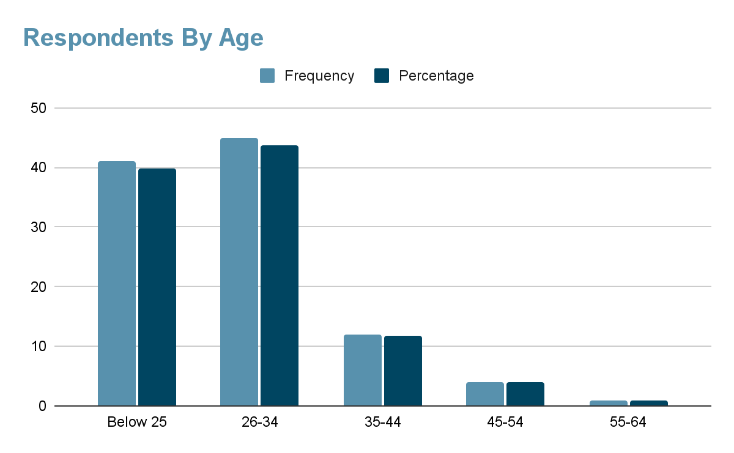

### Extrinsic factors that affect employee motivation

#### Monetary Compensation

Figure 3.2 is a visual presentation of the result obtained when respondents were asked whether their monetary compensation for the work influenced their motivation levels. 42 respondents (40.8%) indicated that they strongly agree with the statement, “The monetary compensation/salary structure has an impact on my level of motivation.”

Following that, 37 respondents (35.7%) said they agreed with the statement. 17 respondents (16.5%) settled with being neutral on the topic of salary structure being a source of motivation for them whereas 6 respondents (5.8%) indicated a disagreement with it. The remaining 1 respondent (1%) opted for strong disagreement that monetary compensation influences an employee’s motivation.

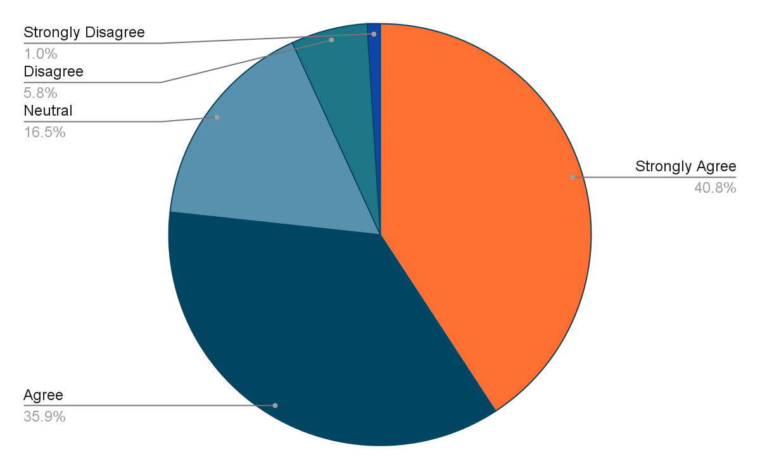

#### Leadership Style

Figure 3.3 shows the results of the questionnaire obtained from respondents when they were asked to agree with the statement, “The style of leadership in the organization has an influence on my degree of motivation at work.” 44 respondents (42.7%) and 38 respondents (36.9%) indicated that they agreed and strongly agreed with the statement respectively. Only 8 respondents (7.8%) disagreed with the statement along with 1 participant (1%) who opted for strong disagreement. The remaining 12 participants (11.7%) stayed neutral on the topic.

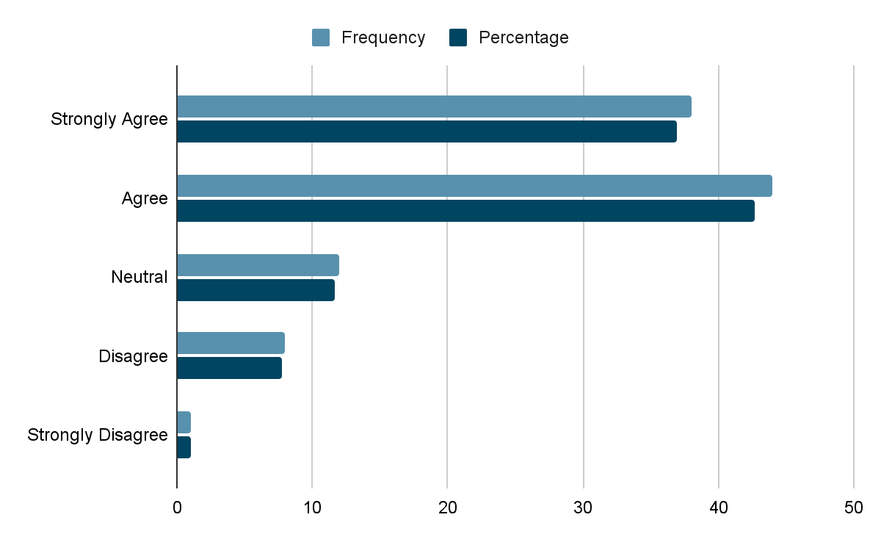

#### Job Enrichment

Figure 3.4 shows the agreement levels of respondents when they were presented with the statement, “The degree of job enrichment embraced by the organization influences my motivation level.” 41 respondents (39.8%) agreed with the statement, whereas 30 respondents (29.1%) remained neutral. 15 respondents (14.6%) disagreed when it came to job enrichment improving their motivations. 17 participants (16.5%) chose to strongly agree with the statement. It’s important to note that 0 participants showed strong disagreement with job enrichment being a factor that impacts motivation.

| **Level of agreement** | **Frequency** | **Percentages** |
| --- | --- | --- |
| Strongly Agree | 17 | 16.5% |
| Agree | 41 | 39.8% |
| Neutral | 30 | 29.1% |
| Disagree | 15 | 14.6% |
| Strongly Disagree | 0 | 0% |

#### Quality Of Working Environment

Figure 3.5 is a representation of the answers obtained from the questionnaire. When respondents were asked to indicate their agreement with the statement that the quality of the working environment affects their motivation in the workplace, 43.7% (45 respondents) indicated agreement whereas 36.9% of respondents (38 respondents) side with strong agreement. 10.7% of respondents (11 respondents) remained neutral on the statement and 6.8% (7 respondents) opted for disagreement. The remaining 1.9% of respondents (2 respondents) chose to strongly disagree with the statement that the quality of the working environment made an impact on an employee’s motivation levels.

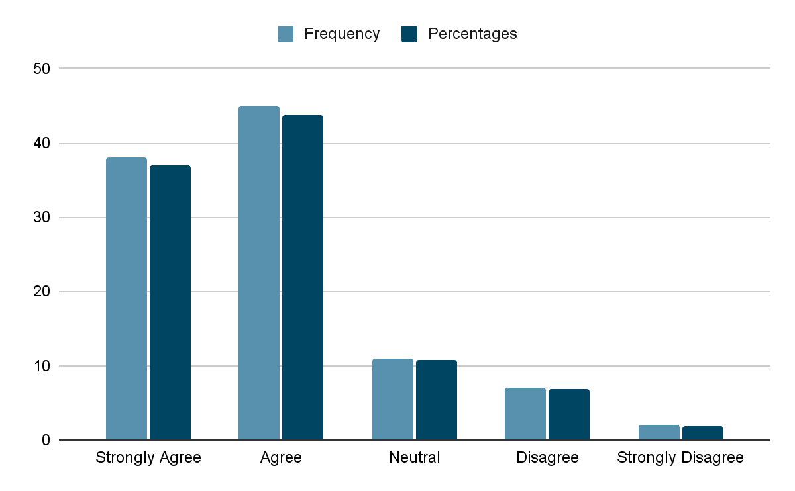

#### Relationship With Manager

In Figure 3.6, you can view a pie chart showing the results of the questionnaire focused on the statement, “The type of relationship between me and the managers of the organization has an impact on my motivation.” 42.7% of respondents (44 respondents) indicated agreement while 40.8% (42 respondents) indicated strong agreement with the statement. The remaining 16.5% of total respondents were divided in such order that 7.8% (respondents) indicated neutrality, 5.8% (6 respondents) indicated disagreement, and 2.9% (3 participants) sided with strong disagreement.

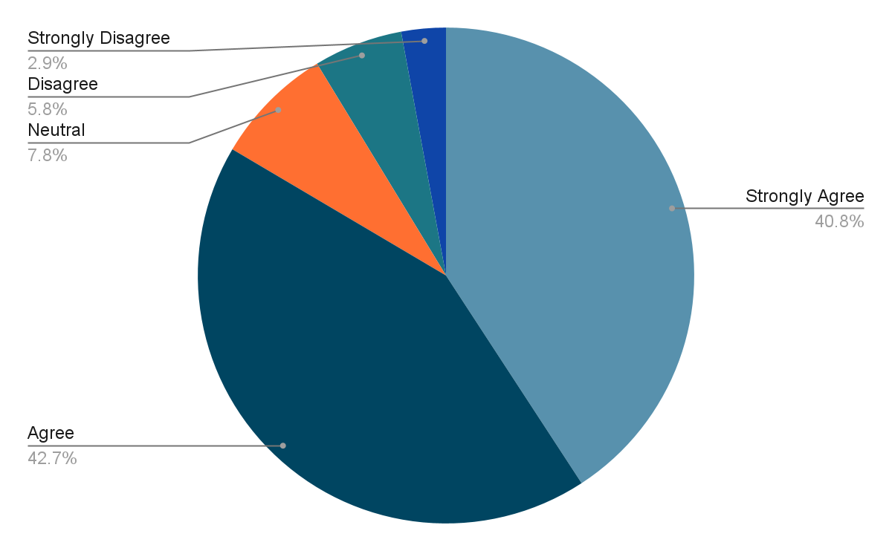

#### Promotion Opportunities

Figure 3.7 indicates the results of the questionnaire that asked respondents to share their agreement with the statement, “The degree to which I believe promotion opportunities exist within the organization has an impact on my motivation.” Out of 103 respondents, 42 respondents (40.8%) agreed with the statement whereas 39 respondents (37.9%) voted with a strong agreement. 9 respondents (8.7%) indicated neutrality on the comment and only 11 respondents (10.7%) said they disagreed with the statement. the remaining 2 respondents (1.9%) were siding with strong disagreement on the subject matter.

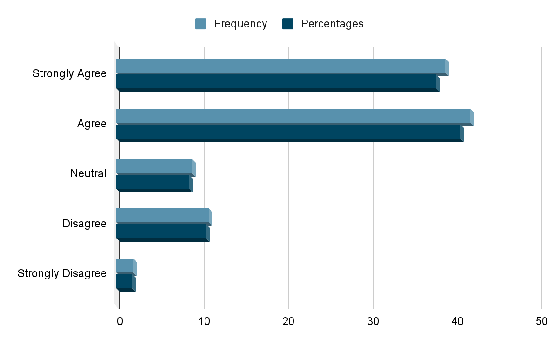

### Intrinsic factors that affect employee motivation

#### Recognition And Appreciation

Figure 3.8 is a representation of the results when respondents were asked to indicate whether recognition and appreciation at the workplace were attributed to motivation levels. 61 out of 103 participants (59.2%) indicated they strongly agreed, followed up by 26 respondents (25.2%) who agreed with the statement. 11 (10.7%) and 3 respondents (2.9%) stayed neutral and disagreed respectively. Lastly, 2 respondents (1.9%) voted for strong disagreement when asked if recognition played a key role in motivation for employees.

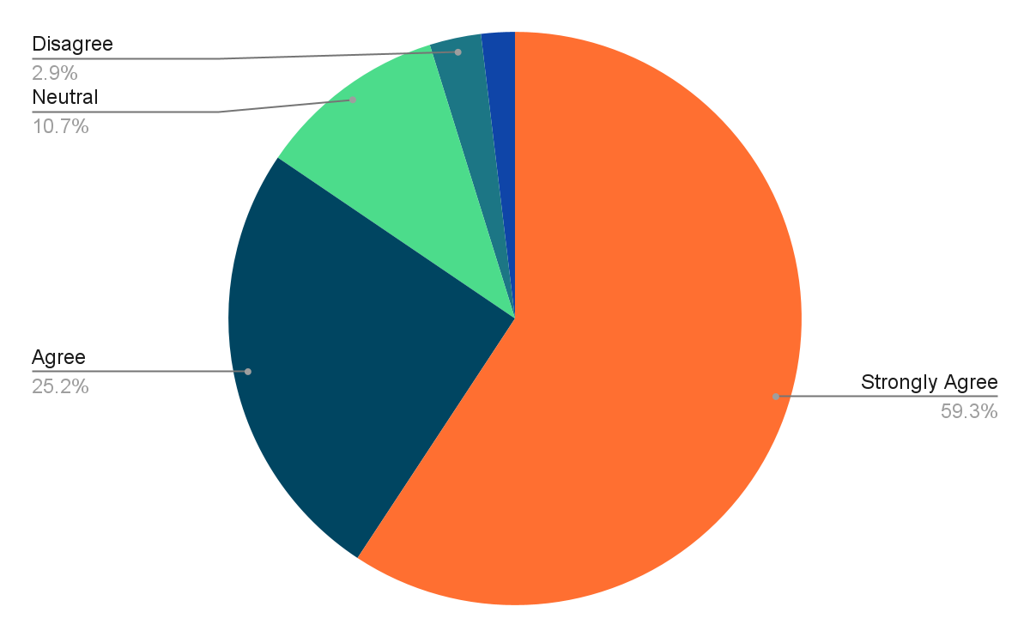

#### Skill Variety

Figure 3.9 shows the results of the answers when respondents were asked to indicate their agreement that skill variety in the workplace is a motivating factor. 41.7% (41 respondents) of 103 respondents agreed that skill variety offered them a motivating edge at work whereas 27.2% (28 respondents) of the remaining respondents chose to strongly agree with it. 23.3% (24 respondents) of respondents remained non-commital to the question and chose to stay neutral. 6.8% (7 respondents) of the respondents said they disagreed with the degree of skill variety being a factor of motivation whereas just 1% (1 respondent) opted to strongly disagree.

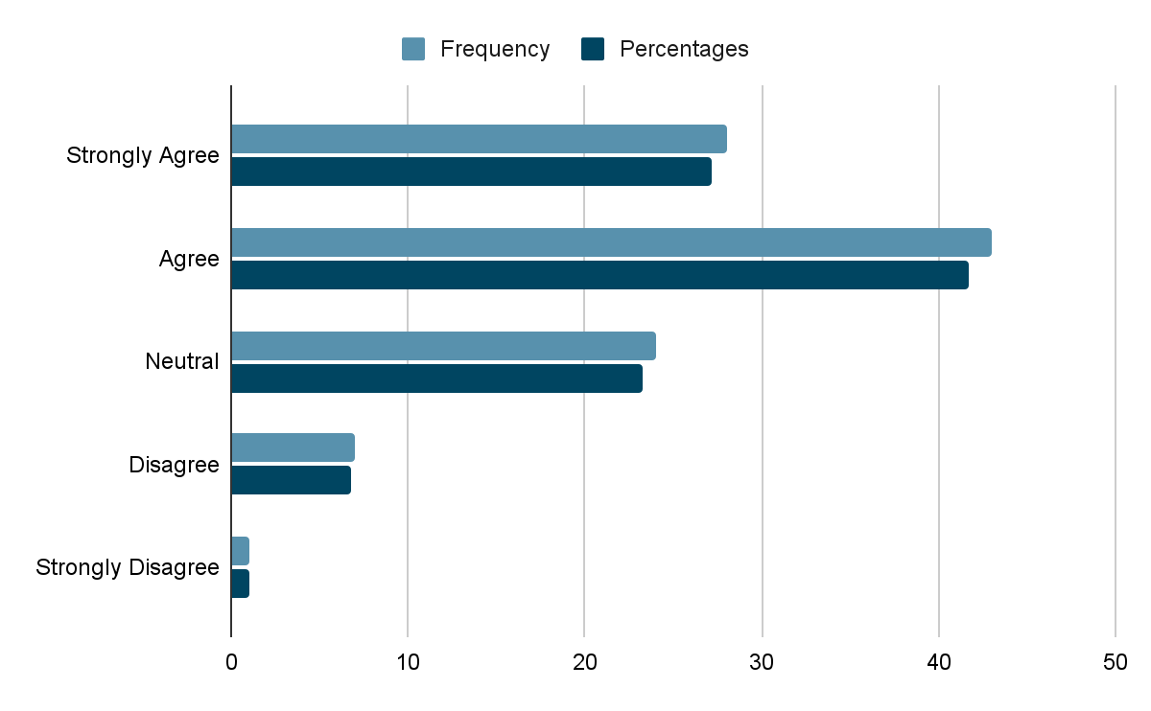

#### Work Meaningfulness

Figure 3.10 is a visual representation of the data collected from respondents when they were asked if meaningful work influences their motivation levels. 47.6% (n = 49) indicated they agreed that meaningful work proved to improve their motivation at the workplace whereas another 25.2% (n = 26) of respondents chose to strongly agree with it. 18.4% (n = 9) of respondents were neutral on the subject and believed it didn’t impact them much in either direction. 6.8% (n = 7) and 1.9% (n = 2) of the remaining respondents were in disagreement or strong disagreement respectively.

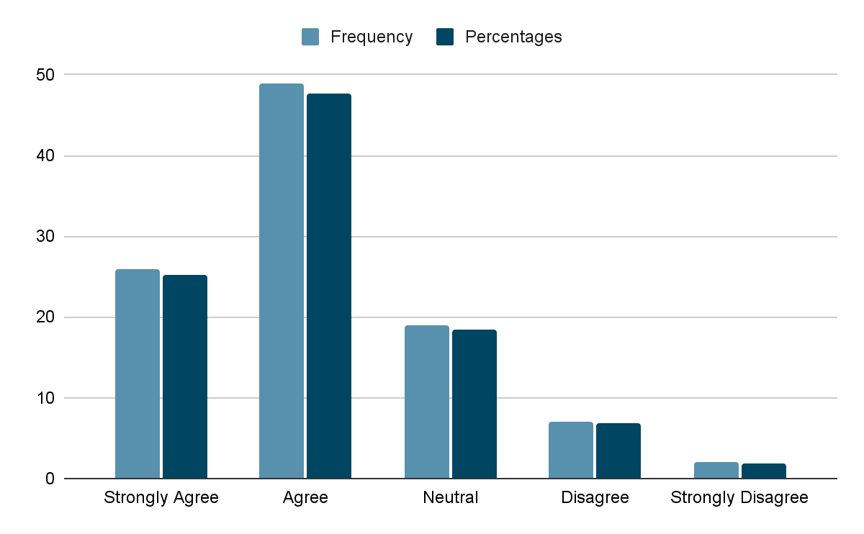

#### Trust

Trust was another factor that was presented to the respondents in the questionnaire and they were asked to indicate how much they agreed that the degree of trust exhibited in the workplace was a contributive factor that influenced the motivation of employees. Figure 3.11 shows how 20 participants (19.4%) strongly agree, followed by 40 participants (38.8%) agreeing that trust plays a crucial role in building motivation in the workplace. However, 36 respondents (35%) stayed non-committal and neutral to the question posed, whereas 5 (4.9%) disagreed that trust had anything to do with motivation. The remaining 2 respondents (1.9%) opted for strongly disagreeing with the subject.

| **Level of agreement** | **Percentages** | **Frequency** |
| --- | --- | --- |
| Strongly Agree | 19.4% | 20 |
| Agree | 38.8% | 40 |
| Neutral | 35% | 36 |
| Disagree | 4.9% | 5 |
| Strongly Disagree | 1.9% | 2 |

#### Responsibility

We have Figure 3.12 which shows the pie chart depicting the answers of respondents when they were asked if the amount of responsibility entrusted with the job was a contributive factor to motivation levels. The results showed that 55.3% of the total respondents (n = 57) agreed and a further 20.4% (n = 21) strongly agreed with the statement. Only 4 respondents (3.9%) disagreed and 2 (1.9%) strongly disagreed with the factor presented. The remaining 18.4% of respondents (n = 19) chose neutrality in this case.

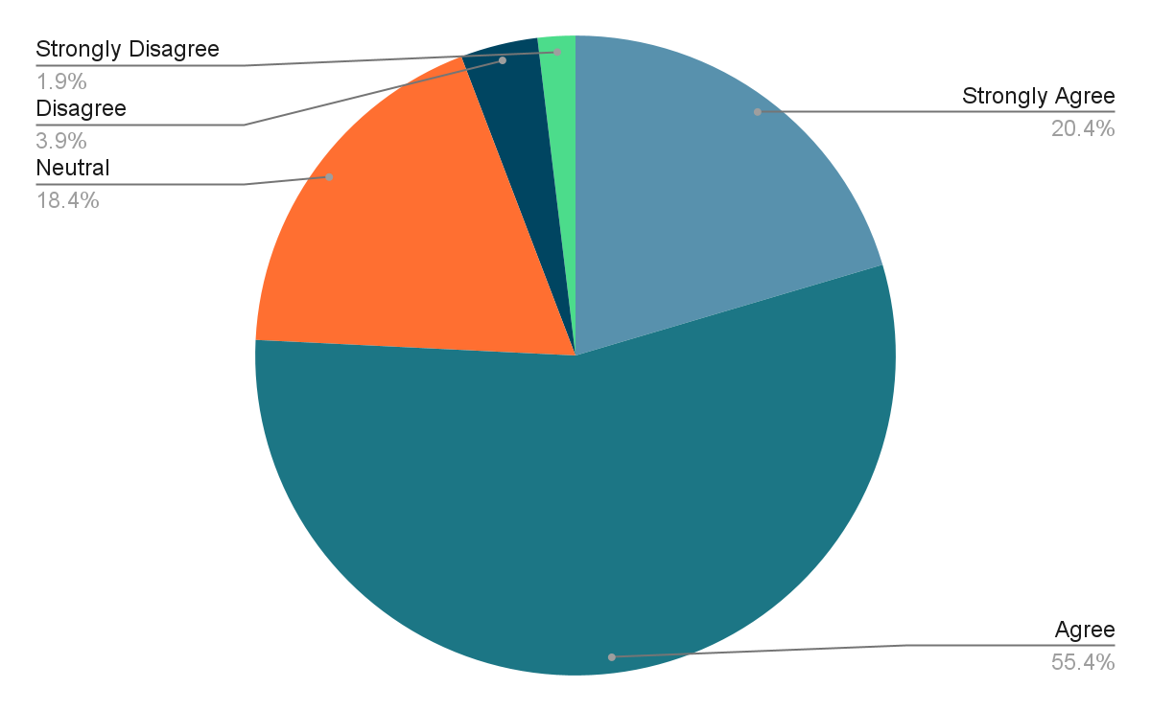

#### Fairness Of Treatment

Figure 3.13 is a tabular form of information that was collected when respondents were asked whether fairness in the workplace had a role to play when it came to motivation levels. 57.3% of the total respondents strongly agreed with the aforementioned statement, and another 32% agreed with it. 6.8% of respondents stayed neutral on the topic and only 3.9% of respondents disagreed with the statement. It’s important to mention that no respondent chose to strongly disagree.

| **Level of agreement** | **Percentages** | **Frequency** |
| --- | --- | --- |
| Strongly Agree | 57.3% | 59 |
| Agree | 32% | 33 |
| Neutral | 6.8% | 7 |
| Disagree | 3.9% | 4 |
| Strongly Disagree | 0% | 0 |

#### Contributive Work

Contributive work being one of the motivational factors was put in the questionnaire and Table 3.14 is the response collected from the respondents when asked for their opinion of it. 51 respondents agreed that contributive work such as those that make significant contributions to the organization act as a motivating factor in the workplace. Another 38 respondents chose to strongly agree with the statement while 13 respondents chose neutrality. Only 1 respondent disagreed with the statement and there were no respondents who strongly disagreed with the statement.

| **Level of agreement** | **Percentages** | **Frequency** |
| --- | --- | --- |
| Strongly Agree | 36.9% | 38 |
| Agree | 49.5% | 51 |
| Neutral | 12.6% | 13 |
| Disagree | 1% | 1 |
| Strongly Disagree | 0% | 0 |

### Impact of employee motivation on work performance

#### Employee motivation directly impacts absenteeism levels

Figure 3.15 shows the result of answers when respondents were asked if absenteeism levels were attributed directly to an employee’s motivation. 41.7% of the respondents agreed and another 25.2% strongly agreed. 24.3% remained neutral while 5.8% disagreed with the statement made. 2.9% of the respondents strongly disagreed.

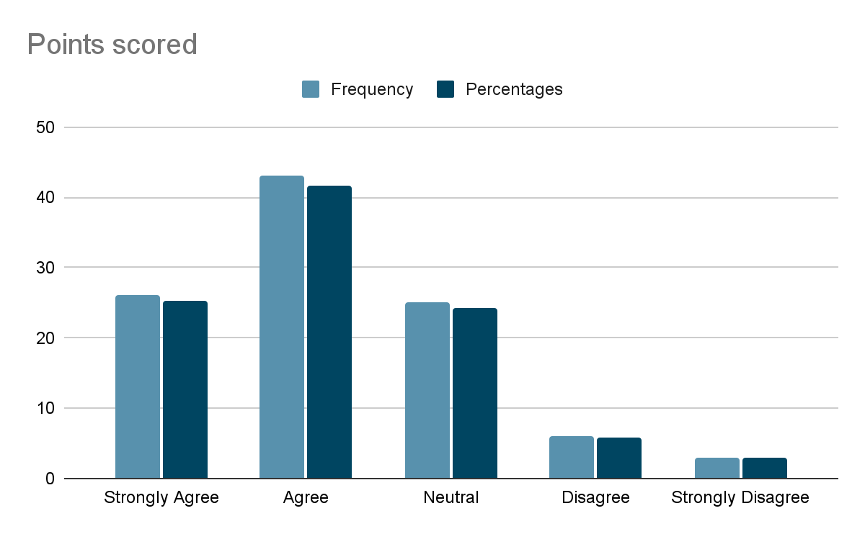

#### Employee motivation directly impacts productivity levels

Table 3.16 represents data collected from respondents. They were asked if productivity levels were directly impacted by employee motivation and 55 respondents agreed. 21 respondents strongly agreed while only 3 strongly disagreed. 19 respondents were non-commital to either agreement or disagreement so remained neutral. The remaining 5 respondents disagreed that motivation directly impacts productivity in the workplace.

| **Level of agreement** | **Percentages** | **Frequency** |
| --- | --- | --- |
| Strongly Agree | 20.4% | 21 |
| Agree | 53.4% | 55 |
| Neutral | 18.4% | 19 |
| Disagree | 4.9% | 5 |
| Strongly Disagree | 2.9% | 3 |

#### Employee motivation directly impacts turnover levels

Figure 3.17 represents data collected from the questionnaire where respondents were asked if turnover rates were directly impacted by employee motivation. We saw 43.7% (n = 45) of the respondents agree with the statement and another 30.1% (n = 31) of respondents showed strong agreement with it. 22.3% (n = 23) of respondents were neutral whereas 3.9% ( n = 4) of the respondents disagreed with the statement.

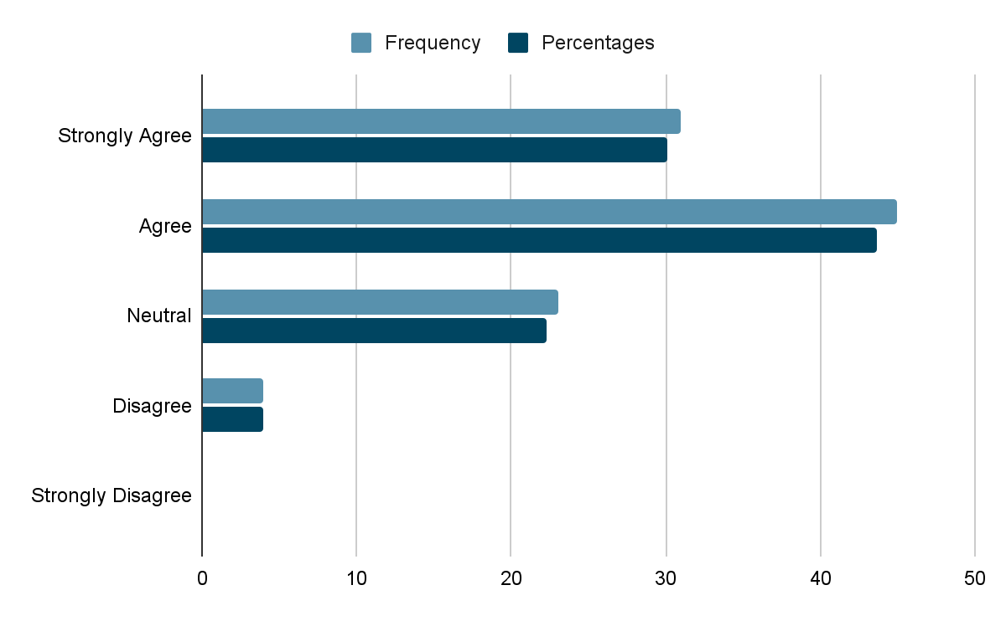

#### Employee stress is linked with workplace motivation

Employee stress being a direct response to workplace motivation levels was also proposed to respondents who were expected to indicate their range of agreement with it. Figure 3.18 shows the results of that section as 40.8% of respondents agreed, 22.3% strongly agreed and 21.4% remained neutral. Only 13.6% of the total respondents disagreed while the remaining 1.9% of respondents chose to strongly disagree with the statement proposed.

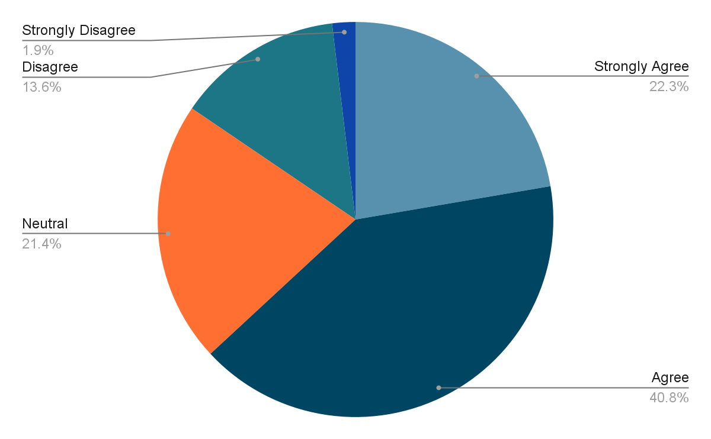

#### Employees’ ability to learn new skills is attributed to motivation

An employee’s ability to learn new skills at their job was a potential motivational factor that was proposed to respondents of the questionnaire. Table 3.19 shows the results when respondents were asked to indicate their agreement. 45.6% of the 103 respondents agreed that it was an attribution to the motivation levels, while 20.4% strongly agreed with the statement. 21.4% of the respondents were neutral and offered to pick neither side of the agreement scale. 12.6% of respondents showed disagreement however there were no participants who strongly disagreed.

| **Level of agreement** | **Percentages** | **Frequency** |
| --- | --- | --- |
| Strongly Agree | 20.4% | 21 |
| Agree | 45.6% | 47 |
| Neutral | 21.4% | 22 |
| Disagree | 12.6% | 13 |
| Strongly Disagree | 0% | 0 |

#### Other Factors that influence employee motivation

Respondents were asked to include other factors that they believed were contributing to the workplace motivation levels at Dow University. This section was mainly focused to bring this research out of the theoretical approach and into the practical reality of our case study of Dow University Hospital. Below is Table 3.20 which shows the suggested factors that influence employee motivation levels at Dow University Hospital along with their frequency and percentages.

| **Other factors** | **Frequency** | **Percentage** |
| --- | --- | --- |
| Overburdened work culture and long working hours | 19 | 16.96% |
| Care for mental and physical well-being | 7 | 6.25% |
| Training sessions and structured learning opportunities should be provided | 8 | 7.1% |
| Employee management relationships should be fostered | 15 | 13.4% |
| Achievement for extraordinary skill display | 8 | 7.1% |
| Respect for the staff | 2 | 1.8% |
| Monetary compensation should be competitive and reflective of work expectations | 10 | 8.9% |
| Recognition of staff contributions | 4 | 3.6% |
| Teamworking spirit | 1 | 0.9% |
| Yearly appraisals | 4 | 3.6% |
| Dynamic growth opportunities | 3 | 2.7% |
| Fairness in treatment of staff | 7 | 6.25% |
| Relationships with colleagues | 2 | 1.8% |
| Inclusion of staff in important decision making that has direct impacts | 4 | 3.6% |
| Availability of an understanding and approachable HR authority/management | 6 | 5.4% |
| Critical allowances, health checks and basic emergency insurances for family | 4 | 3.6% |
| Being equipped with proper guidelines, skills and working environment to remain productive | 3 | 2.7% |
| Extra incentives such as sick leaves, contractual leaves and vacation days | 5 | 4.5% |

## 

## Data Analysis

This section is dedicated to address the findings of the questionnaire and elaborate on the factors that influence employee motivation levels at Dow University Hospital. These findings are based on the responses from the questionnaires filled out by employees of the aforementioned institute and the researcher aims to provide a clear depiction of a thorough analysis.

### Extrinsic Factors That Impact Employee Motivation Levels

The findings of the research conducted showed that a healthy relationship with managers, quality of the working environment, and leadership style in the workplace was the most important extrinsic factors that influence the motivation of employees in Dow University Hospital.

This finding agrees with the study of Aziz H. (2021) which identified that working environment and culture are the main motivational factors. The concept is that employees who believe their organization treats them positively via a democratic leadership style enjoy a boost in their interpersonal loyalty to the company. This consequently boosts their effectiveness and efficiency in the workplace. Workers with a mighty sense of commitment to a company also feel ownership, unlike other employees who don’t feel such obligations. This trickles down into the sense of ownership acting as a driving force of motivation and work considered to be the best potential.

According to Vo. (2022), managers have a crucial responsibility to ensure a productive and motivating work climate and to enrich their employees to their full potential. Normally, these performances depend on many factors such as motivation, training, and job satisfaction. However, motivation is the subject of this research paper and has been shown to influence performances to a larger degree.

Healthy relationships with managers are the most agreed-upon factor in the questionnaire with 83.5% of total respondents agreeing with it. This can be reasoned with an article stating, “Prosocial motivation strengthens performance, endurance, and productivity,” (Vo, 2022). Healthy relationships with managers encourage problem-solving of work matters that impact productivity in the workplace. It also improves the feeling of job stability and security, fostering a healthy environment where trust and communication come first.

Furthermore, working environments also are a largely agreed-upon factor that impacts motivation in this research’s findings. Work environments are proven to impact mood, drive, mental health, and work performance. The ecological systems theory offers a lot of explanations to shape the workplace environment, along with the social exchange theory which states that favorable working environments provide motivation to employees (Christensen-Salem A, 2021). These working conditions enable employees to feel more dedicated and focused on the tasks at hand and ultimately result in favorable performance results.

### Intrinsic Factors That Impact Employee Motivation Levels

Findings of this research study revealed that the top three intrinsic factors impacting motivation levels are fairness in the workplace, significance of contribution and recognition, and appreciation. Intrinsic factors are highly variable across each individual and remain unquantifiable to judge.

89.3% of total respondents agreed with fairness being of utmost importance and this finding remained aligned with multiple studies conducted on the specificity of this motivational factor. Recent research revealed that employees often observe and react to decisions in the workplace that are aligned with former expectations. Hence, employees who feel fairness is a common practice in the workplace will be fair in their work obligations and exhibit greater signs of loyalty and commitment, improving their productivity and motivation along the way ([Matthias Seifert](https://sloanreview.mit.edu/article/how-workplace-fairness-affects-employee-commitment/#article-authors), 2015).

According to Kalimullah, appreciation, and recognition in the workplace enhances employee motivation and job satisfaction. Recognition and reward make employees feel like a useful and rewarded part of the organization, making them contribute more positively to maintain their extraordinary recognition.

Lastly, employees agreed that the significance of their contributions was one of the main contributors to motivation. This is because most people find intrinsic rewards just as important as monetary benefits. So high-paying jobs with meaningless tasks proved to be demotivating for the workers. A worker who finds their tasks meaningless will face a depression of motivation despite having favorable extrinsic factors such as high pay, healthy work relationships and effective communication with management.

### Impact Of Employee Motivation On Workplace Performance

The findings of the questionnaire tailored for this study found that most respondents believed that absenteeism rate, productivity levels, and employee turnover were all results of low motivation in the workplace. Absenteeism affects work performance as employees withdraw from the organization due to job dissatisfaction, leaving behind a trail of financial and expected output lag.

These findings agree with Anderson (2004) and note that it is a result of job dissatisfaction that propels unsatisfying and stressful work situations. Absenteeism also comes from the lack of motivation to attend work or provide optimal output in their performance. Consequently, Vlosky and Aguilar highlight the effect of absenteeism on the organization, increasing costs of low productivity and ineffectiveness within the working environment (Anderson, 2009).

When discussing how employee productivity is impacted by motivation, Wentzel and Wigfield (2009) said it best. Their statement concluded that productivity impacts motivation in terms of the long-run success of a business. Improved productivity means the organization finds a way to be more efficient with fewer resource requirements and hence reaches a peaked ratio of input to output (Miele D., 2009). This, in turn, drives down the costs of the organization, enables it to compete as a market leader, become a preferred organization for cut-throat employees, and gain a large portion of the market share. With higher profits, minimal waste of scarce resources, and a positive image, the organization is intended to enjoy long-run success and stability.

Lastly, employee turnover affects motivation in a way that high turnover results in remaining employees feeling insecure. They often have to pick up the slack of former employees as well, resulting in poor morale, overburdened working conditions, and comparatively lower pay (Dipietro, 2007). These feelings and conditions of the workplace translate to unmotivated or possibly demotivated employees who choose to then withdraw their loyalty from the organization.



## Introduction

This chapter focuses on the findings of the primary data collected from the questionnaire in regard to the topic of this research paper. The researcher provides a thorough conclusion of the findings, objectives, and analysis of the research. Recommendations are also further provided.

## Conclusion

### Extrinsic Factors

Motivation is a deep concept that has an array of connected and intervening factors. The extrinsic factors come from the environment that an employee is placed within. Most of these factors are also easily controlled by the management and hence are quantifiable such as monetary compensation and working environments. The manner in which the organization handles these extrinsic factors will immediately reflect upon employee morale and motivation.

### Intrinsic Factors

Intrinsic factors are important when it comes to motivation linked with job satisfaction. These factors deal with the emotions and perceptions of every individual employee which makes it an unquantifiable force. For instance, the level of trust exhibited is an inherent factor of motivation and will vary from employee to employee because it is subjective in nature.

### Impact of Motivation On Performance

The main reason for researching motivation is its translation into employee performance. It’s important to understand which factors can improve or decrease motivation so that an organization can focus on motivating employees for better results. The benefits that any organization will enjoy from motivated employees are numerous such as increased profits, market leadership, competitive edge, minimal waste of precious resources, and long-run successes. Hence, HR departments should look into motivating factors and implement them in the workplace using informed decision-making.

## Recommendations

Considering all that has been revealed in this research, the study makes the following recommendations.

### Recommendation for improving motivation

#### Extrinsic factor recommendations

In order to improve motivation extrinsically, management should begin by offering monetary compensation and fringe benefits throughout the year. As the research paper focuses on a hospital that calls for stressful career calls, the overburdened and stressed employees could feel much more committed to a workplace that offered them overtime pay, flexible working shifts, and performance bonuses. Additionally, for extraordinary performances during peak hours or crisis cases, employees can be offered monetary rewards as a form of recognition.

When it comes to fringe benefits, offering insurance packages for an employee’s family can be a strong start for most employees. In a developing country like Pakistan with almost no availability of free public healthcare, employees will most likely find this as a huge motivational boost. Offering critical health allowances and sick days off can be further recommended for employees and can offer them a reason to stay motivated at work to enjoy these fringe benefits.

Secondly, the management should enforce a favorable working environment with minimal distractions and important tools to ensure productivity and motivation. At a location such as a hospital, having quiet break rooms is essential for essential workers. Filled with healthy snacks and temperature control, these break rooms can deliver a strong message to employees that the HR department understands their concerns and wants to recognize their efforts in the organization.

The researcher believes that promotional opportunities should also be offered frequently to deserving staff. The promoting board should enable fairness by conducting an analysis of employee performance. Rewarding longstanding employees with promotion or growth opportunities within or externally can solidify employees’ loyalty to the organization.

Furthermore, it must be noted that offering job-enriching activities such as seminars, training lessons and colleague competitions every once in a while can strengthen a healthy relationship of an employee with his/her job in the organization as well as the management. An employee of the month is one example of such activity within the organization.

#### Intrinsic factor recommendations

According to a study published in Perspectives on Psychological Science, researchers revealed that general curiosity is significant in motivating great performance. This curiosity can be used by management to target multiple intrinsic factors of motivation. The researcher recommends the introduction of “Insight Sessions” at Dow University Hospital but this model will fit multiple organizations throughout the world.

In an Insight Session, employees should be taken on a tour with their managers and shown the impact their work makes in the lives of others. Considering the institute of this case study, employees could be socialized with the patients that they have directly or indirectly influenced by their work. This provides a face and moral value for their job and will significantly improve motivation and productivity. For employees in the finance departments, Insight Sessions can look like profit reports and the use of extra profits in the development of the organization such as health camps. The Insight Sessions can be tied to the intrinsic factor of the significance of the task on the organization.

Another way to target intrinsic factors of motivation is to offer mentorship programs. In the questionnaire provided to the employees of Dow University Hospital, some respondents emphasized the lack of an understanding and healthy relationship with their managers and departments. They also indicated a lack of proper training and guidelines that can effectively propel their career. Hence mentorship programs can help these employees gain a positive relationship, seek valuable knowledge and gain motivation. Connecting these employees with higher-level officials of their career can help them grow and master their skills, making them an incredible asset to the Hospital. This also opens up an open communication line on both ends hence in-house mentorship or training programs are highly recommended.

Recognition and reward programs can be exciting and become an incredible source of motivation for employees. Research has revealed that recognition programs can keep over 66% of participating employees motivated at work. These recognition programs can stir friendly competition amongst peers, increasing social relationships at the workplace and creating an environment of growth, trust and security. Even though rewards hold extrinsic nature, the motivational boost is from the internality of an employee.

## Recommendations for Future Research

Future researchers should conduct a study on the impact of employee motivation within the public and private sectors of Pakistan to grasp a wider understanding of this topic. Future studies can also focus on building controlled environment to calculate the extent of which one factor extends itself to change motivation while all other factors remained controlled. Hence, this would help explain the strongest factors of motivation which can do incredulously for organizations around the globe. Any future research can also use this current study as part of their investigation and literature review to better understand the concept of employee motivation.

# References

Al-Sada, M., Al-Esmael, B., & Faisal, M. N. (2017). Influence of organizational culture and leadership style on employee satisfaction, commitment, and motivation in the educational sector in Qatar. *EuroMed Journal of Business.*

Alshmemri, M. S.-A. (2017). Herzberg’s two-factor theory. *Life Science Journal*, 14(5), 12-16.

Anderson, J. R., Bothell, D., Byrne, M. D., Douglass, S., Lebiere, C., & Qin, Y. (2004). An integrated theory of the mind. *Psychological review*, 111(4), 1036.

Aziz H, Othman B, Gardi B, Ahmed S, Sabir B, Burhan Ismael N, et al.. *Employee commitment: the relationship between employee commitment and job satisfaction. J Humanit Educ* *Dev*. (2021) 3:54–66. 10.22161/jhed.3.3.6

Barney, C. E. (2010). *Flex‐time as a moderator of the job stress‐work motivation relationship: A three nation investigation. Personnel Review.*

Bawa, M. A. (2017). Employee motivation and productivity: a review of literature and implications for management practice. *International Journal of Economics, Commerce and Management*, 12, 662-673.

Bénabou, R. &. (2003). Intrinsic and extrinsic motivation. *The review of economic studies*, 70(3), 489-520.

Christensen-Salem A, Mesquita LF, Hashimoto M, Hom PW, Gomez-Mejia LR. *Family firms are indeed better places to work than non-family firms! Socioemotional wealth and employees' perceived organizational caring. J Fam Bus Strateg.* (2021) 12:100412. 10.1016/j.jfbs.2020.100412

Cooper, D. R. (2011). *Business Research Methods, 11th ed.* USA: McGraw-Hill Irwin International Edition.

Cummings, L. L. (1968). Empirical research on the bases and correlates of managerial motivation: A review of the literature. *Psychological bulletin*, 70(2), 127.

Dipietro, R. B., & Condly, S. J. (2007). Employee turnover in the hospitality industry: An analysis based on the CANE model of motivation. *Journal of Human Resources in Hospitality & Tourism,* 6(1), 1-22.

Dysvik, A. &. (2010). Exploring the relative and combined influence of mastery‐approach goals and work intrinsic motivation on employee turnover intention. *Personnel review*.

Falk, A. (2014). Fairness and motivation. *IZA World of Labor*.

Fishbach, A. &. (2022). The structure of intrinsic motivation. *Annual Review of Organizational Psychology and Organizational Behavior* , 339-363.

Fisher, D. M. (2012). Facet personality and surface-level diversity as team mental model antecedents: implications for implicit coordination. *The Journal of applied psychology*, 97(4), 825–841.

Furnham, A. (2006). Money as a motivator. *In Management Mumbo-Jumbo*, 92-94.

Gawel, J. E. (1996). Herzberg's theory of motivation and Maslow's hierarchy of needs. *Practical Assessment, Research, and Evaluation*, 5(1), 11.

Hansen, F. S. (2002). Rewards and recognition in employee motivation. *Compensation & Benefits Review*, 34(5), 64-72.

Kaiser, C. P. (2018). Absenteeism, presenteeism, and workplace climate: A taxonomy of employee attendance behaviors. *Economics & Business Journal: Inquiries & Perspectives*, 9(1), 69-86.

Kaur, S. (2021). SAMPLE SIZE DETERMINATION. *International Journal of Current Research*, 48365-48367.

Khan, K. U. (2010). The relationship between rewards and employee motivation in commercial banks of Pakistan. *Research journal of international studies*, 14(3), 37-52. .

Kocakulah, M. C. (2016). Absenteeism problems and costs: causes, effects and cures. *International Business & Economics Research Journal (IBER)*, 15(3), 89-96.

Larson, R. W. (2011). Intrinsic motivation and positive development. *Advances in child development and behavior*, 89-130.

Locke, E. A. (1976). An experimental case study of the successes and failures of job enrichment in a government agency. *Journal of Applied Psychology*, 61(6), 701.

Long, J. J. (2018). Chronic conditions: A motivator for reexamining the effectiveness of promotions and communications of organizational wellness programs. *International Journal of the Academic Business World*, 12(1), 39.

Martin, A. J. (2005). The role of positive psychology in enhancing satisfaction, motivation, and productivity in the workplace. *Journal of Organizational Behavior Management*, 24(1-2), 113-133.

[Matthias Seifert, Joel Brockner, Emily C. Bianchi, and Henry Moon](https://sloanreview.mit.edu/article/how-workplace-fairness-affects-employee-commitment/#article-authors) (2015). *How workplace fairness affects employee commitment, MIT Sloan Management Review.*

McClelland, D. C. (2008). Power is the great motivator. *Harvard Business Review Press*.

McLeod, S. (2007). Maslow's hierarchy of needs. *Simply Psychology*, 1(1-18).

Miele, D. (2009). *Handbook of motivation at school* (Vol. 704). K. R. Wentzel, & A. Wigfield (Eds.). New York, NY: Routledge.

Naile, I. &. (2014). The role of leadership in employee motivation. *Mediterranean Journal of Social Sciences* , 5(3), 175.

Orpen, C. (1979). The effects of job enrichment on employee satisfaction, motivation, involvement, and performance: A field experiment. *Human relations*, 32(3), 189-217.

Riyanto, S. S. (2017). The impact of working motivation and working environment on employees performance in Indonesia stock exchange. *International Review of Management and Marketing*, 7(3), 342-348.

Skudiene, V. &. (2012). The contribution of corporate social responsibility to internal employee motivation. *Baltic journal of management*.

Steger, M. F. (2016). Creating meaning and purpose at work. *The Wiley Blackwell handbook of the psychology of positivity and strengths‐based approaches at work*, 60-81.

Ton, Z. &. (2008). Managing the impact of employee turnover on performance: The role of process conformance. *Organization Science*, 19(1), 56-68.

Turkyilmaz, A. A. (2011). Empirical study of public sector employee loyalty and satisfaction. *Industrial Management & Data Systems*.

Vo, T. T. D., Tuliao, K. V., & Chen, C. W. (2022). *Work Motivation: The Roles of Individual Needs and Social Conditions. Behavioral sciences* (Basel, Switzerland), 12(2), 49.